Digital Payment Adoption
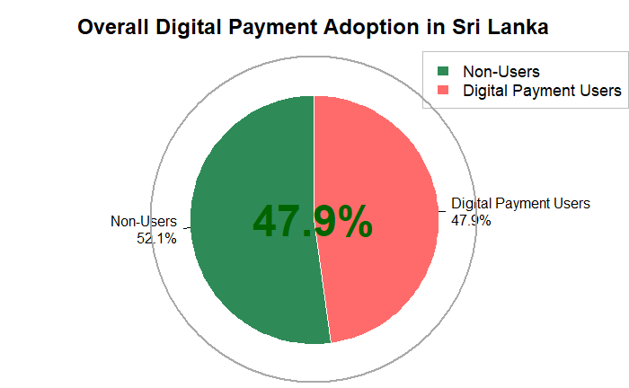
Complete Use of Digital Payments
Data shows that the majority (47.9%) of people surveyed in Sri Lanka have engaged in digital payment transactions, while 52.1% have not. Therefore, a large portion of the Sri Lankan population is actively involved in using digital channels for transaction purposes, but there is still somewhat of a plateau in terms of the total amount of digital payments made. Sri Lanka is currently at a place of potential growth and future digital adoption as more people gain access to digital services and further barriers to digital involvement are reduced. The gap of 4.2 percentage points between users and non-users is indicative of the current point of change for the country.
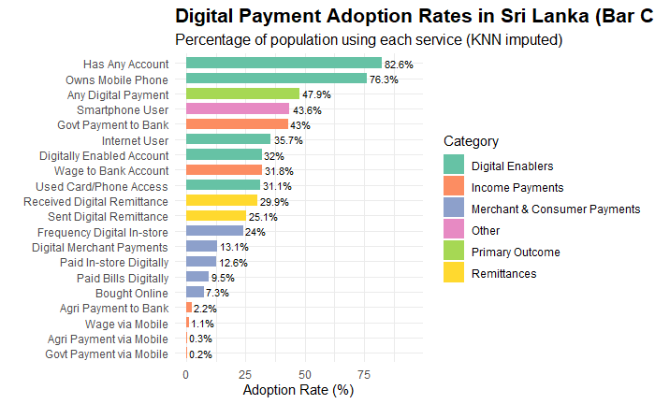
"The bar graph shows that 84% of people in Sri Lanka have an account and 83% of people in Sri Lanka have a mobile phone - a good level of basic access for digital services. Digital payments are only used by 48% of the population.
There is a close relationship between the amount of people who have a smartphone (47%) and the amount of people who use digital payments. People use digital income streams like their wages (29%) and government payment (38%) casually.
Active use of digital payment methods (receiving and sending digital remittances (15-19%); paying bills digitally (12%); paying for goods and services (14%)) is still relatively low."
The figure illustrates the percentage of Sri Lankans as reflected in this sample of 1,000 persons who have adopted digital payment methods.
There are a total of 1,000 people:
1. Maximum adoption (largest number of people having access to digital goods) - 840 are bank account holders; 830 are mobile phone owners.
2. Core adoption (approximately 490) - 480 individuals utilize digital payment.
There are 470 individuals with smartphones.
3. Digital Income (300-to-400); 380 individuals receive payments to bank accounts via the government. 290 individuals receive their wages by direct deposit into checking accounts.

4. Low Adoption (fewer than 200) - 190 receive digital remittances and send digital remittances to 150 people.
5. Very Low Adoption (fewer than 150) - 140 people make payments to digital merchants and 120 people use digital bill payment; 90 have received agricultural payments into their bank account.
Conclusion: Of the 1,000 individuals sampled, most have basic access to things such as bank accounts and mobile phones, but only about half use digital payment methods. Fewer than 150 people make daily digital transactions (e.g., shopping and paying their bills).
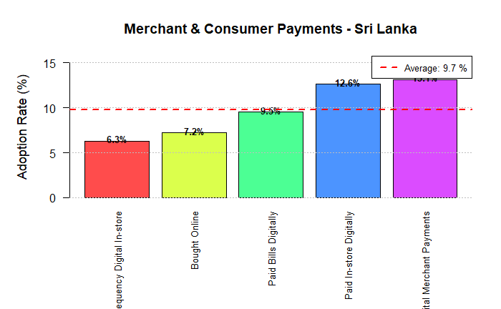
Adoption rates are low among consumers and merchants for specific types of digital payment methods, as illustrated by this chart showing an average of 9.7% digital payment adoption in Sri Lanka.

The activity category with the highest adoption rate is Paying Bills Digitally (12.6%), followed closely by Digital Merchant Payments (9.5%), with no numeric value reported for Paid In-Store Digitally, but which clearly shows another low adoption rate.

Thus, while almost half of the Sri Lankan population uses digital payment methods, they do not use them consistently for daily transactions at stores, with merchants, or for paying bills, as evidenced by the digital payment penetration being approximately 10%; therefore, there is a significant gap between consumers who have digital access to pay for goods and services and actually using these methods to make day-to-day purchases.
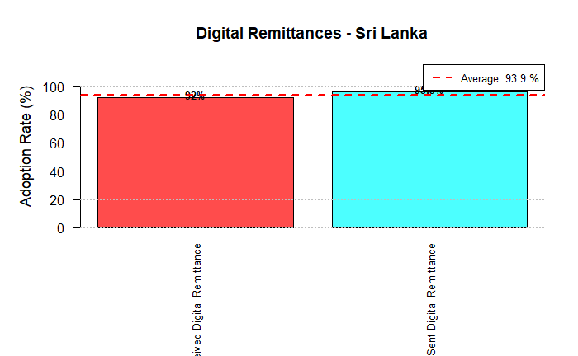
Digital remittances are well below both the total rate of digital payment adoption (47.9%) and the already low rates of digital merchant payments (around 9.7%). Digital remittances represent, by far, the least adoption of all of the types of digital financial behaviors measured in the research.

Account and Phone Ownership
While Sri Lankans have ~84% banks account ownership and ~83% mobile phone ownership, the volume of money transferred electronically between family and friends within Sri Lanka using those tools is minuscule. Thus, it is clear that most domestic transfers of money are conducted via traditional, non-electronic means (i.e. cash, hawala). This discrepancy between high rates of access and minimal use of services is a major untapped market for digital financial services that provide peer-to-peer transfer solutions.

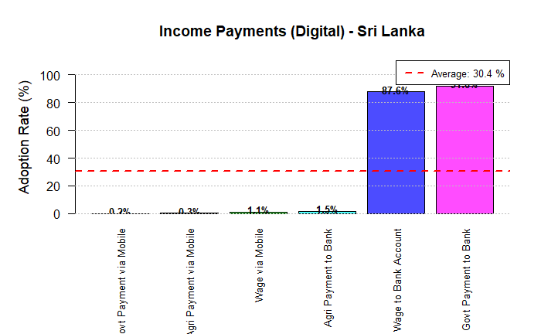
The chart below compares several types of income received digitally by Sri Lankans with each type of income providing significant differences in how much income is received digitally but with overall total adoption at just 30.4% with one method accounting for a lion's share of those total numbers; therefore, the method used most frequently by Sri Lankans to receive digital-based income was through the government's payment to bank method, representing 37.6% of all digital-based income received by Sri Lankans, demonstrating that the digitization initiative of support programs and salaries by the government is contributing heavily toward financial inclusion in the nation.

Furthermore, the next highest level of digitized income received was from receiving wages to a bank account at 28.9%, indicating a strong reliance on cash and non-digital payments for private sector employment income. In addition, there is minimal utilization of digital channels to receive income related to agriculture or mobile phone payments, including Agri Payments to Bank (1.5%), Govt via Mobile – 0.2%, Wages via Mobile – 0.3% and Agri via Mobile (1.1%), illustrating a significant gap in the digitization of agricultural and rural/iinformal economy income payments.

Key Takeaway: In Sri Lanka, the predominant drivers of income digitization are G2P payments to bank accounts, with minimal use of mobile money services for paying wages or agricultural payments. This illustrates how Sri Lankan relies upon traditional banking systems for formal income channels and has left multiple segments of the
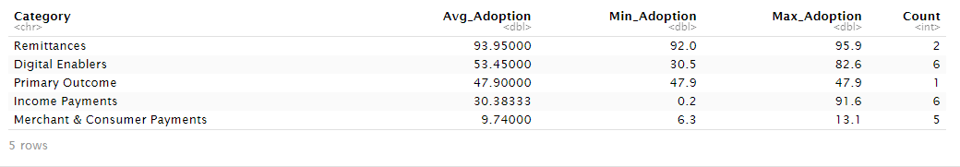
The table below shows rankings of adoption of categories related to the digital financial ecosystem in Sri Lanka, proceeding from the least adopted category up to the most adopted category:
1. Remittances (3.95% mean): This is evidently the least adopted category, as shown by the 3.95% mean for sending/receiving money digitally with your family/friends is all but nonexistent.
2. Merchant & Consumer Payments (9.74% mean): Usage of digital payments for daily spending (in-store, online, bill payments etc) is also quite low, with the mean being 9.74%, indicating that there exists an even greater disparity between having access to digital payments and using them actively.
3. Income Payments (30.38% mean): Receipt of income digitally (whether in the form of wages or government payments) has a modest level of adoption with a high degree of variation (0.2% - 91.6%) primarily due to receipt of government payments directly into bank accounts.
4. Primary Outcome (47.9%): The Primary Outcome which is the use of any digital payment method reflects that almost half (47.9% or approximately 12.9 million) of the total population living in Sri Lanka is engaged in the digital economy at an entry-level.
5. Digital Enablers (53.45% average): Foundational access to the digital financial ecosystem (e.g. owning a phone or bank account) leads to the largest category of adoption. This alludes to the fact that the reason for the lack of adoption of digital payments is not that people do not have the necessary tools, but that they do not use those tools on a routine basis.

In conclusion, Sri Lanka has an adequate digital infrastructure (52% or ~41 million) but only half of the country has made any use of digital payments to any degree (approximately 47.9% or ~12 million). However, daily usage of digital payments for regular transactions is extremely low (all under approximately 10%) demonstrating a clear need for more widespread use of digital payment methods through the creation of applications which stimulate regular adoption of digital payments.
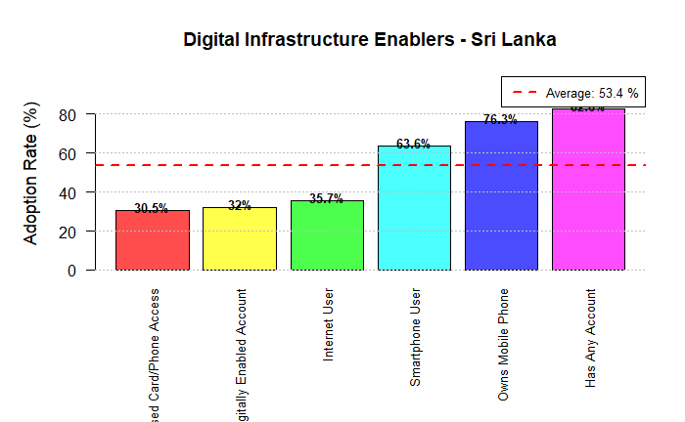
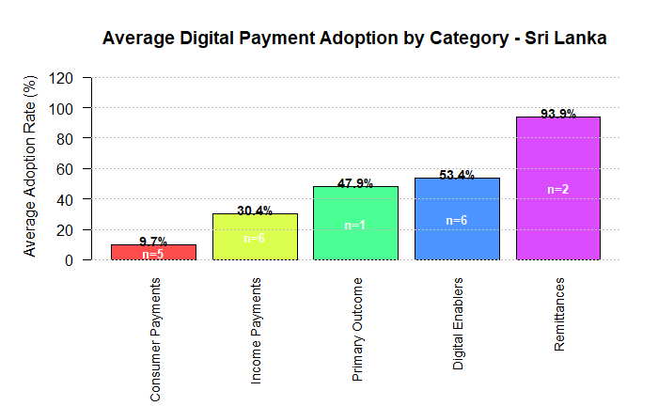
Interpretation of the Diagram (Average Digital Payment Adoption by Category - Sri Lanka)
Highest Adoption
The adoption of remittances (approximately 93.9 percent) is the highest level of digital payment usage in Sri Lanka. This indicates a very strong level of digital channel usage (e.g., Smart Money and Internet) to send and receive money.

Moderate Adoption
Digital enablers have an adoption rate of about 53.4 percent, and primary outcome (which includes things like bus passes, tolls, etc.) are right around 47.9 percent, indicating digital payment usage is steady but not universal in these categories.

Lowest Adoption
Income payments only have an adoption rate of approximately 30.4 percent. Consumer payments represent a very low proportion of digital payment usage at approximately 9.7 percent, indicating that a majority of cash payments are still being made for day-to-day purchases.

In summary, adoption of digital payments in Sri Lanka is high for remittance transactions, but daily consumer payments and income payments lag behind. Therefore, increasing merchant acceptance and promoting digital wage and consumer payments are areas that need improvement.
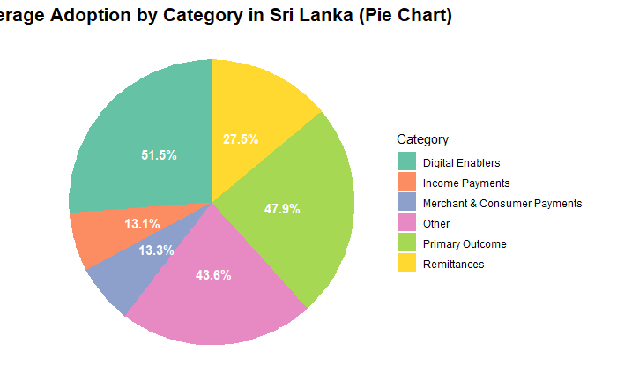
Chart Interpretation (Average Category Adoption - Sri Lanka)

- The largest portion was held by Digital Enablers (51.5%).
- High areas of adoption were Primary Outcome (47.9%) and Other (43.6%).
- Remittances (27.5%) experienced moderate adoption.
- The lowest area of adoption was found with Income Payments (13.1%) and Merchant & Consumer Payments (13.3%).

Thus, the overall conclusion based on this pie chart is that in Sri Lanka, Digital adoption is prevalent through enablers and particular outcomes. However, routine payment options are lacking as evidenced by their relatively low adoption rates. As a result, additional efforts should be made to promote routine usage of Digital Payment options.
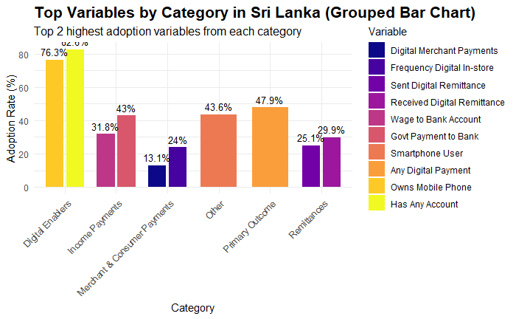
Key Insights from the Grouped Bar Chart (Top Categories Ranked by Volume - Sri Lanka)
- Highest Share:
- Digital Enablers (76.3%): There is a high level of access to Digital Infrastructure and Digital Tools as this category represents the greatest proportion of usage.
- Item with Highest Level of Digital Adoption:
- Primary Outcomes (47.9%) and Other (43.6%) categories are well represented and provide evidence of moderate usage of Digital Solutions.
- Moderate Level of Contribution:
- Remittances (25.1%), while representing a noticeable amount of Digital Usage do not dominate the overall amount of Digital Usage.
- Category with Lowest Level of Digital Adoption:
- Income Payments (13.1%) and Merchant and Consumer Payments (13.3%) have the highest degree of lack of Digital Usage indicating limited amounts of Digital Solutions used for routine transactions.
Conclusion:
Overall, Digital Adoption in Sri Lanka is very high in regard to Digital Enabler use; whereas Digital Adoption for Routine Payments and Remittances is much lower in comparison representing opportunities for promoting Increased Use of Digital Payment Solutions for Routine Transactions.

Relevant files have been created that document the outcome of KNN Method (with imputed data):
• gender_adoption_sri_lanka_knn.csv
• age_adoption_sri_lanka_knn.csv
• income_adoption_sri_lanka_knn.csv
• payment_types_sri_lanka_knn.csv
Analysis has been completed
The purpose of this analysis is to create a complete understanding of digital payment adoption in Sri Lanka through the use of KNN Imputation (K=5) to reduce the number of Missing Data records.
Based on the key findings from this analysis, data has been exported into CSV files for potential future use.
The analysis presents graphical representations of the digital payment adoption patterns throughout Sri Lanka.
Data Processing Summary
• Total number of Missing Values (Records) before KNN Imputation = 6598 (25.38%)
• Total Number of Missing Values after KNN Imputation = 0 (0%)
• Total number of respondents included in the analysis = 1000 respondents
• Total number of Variables used in the analysis = 26
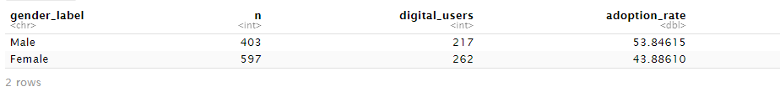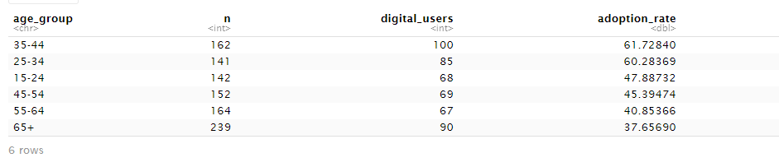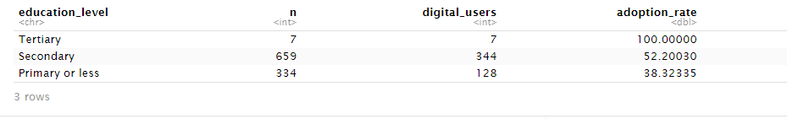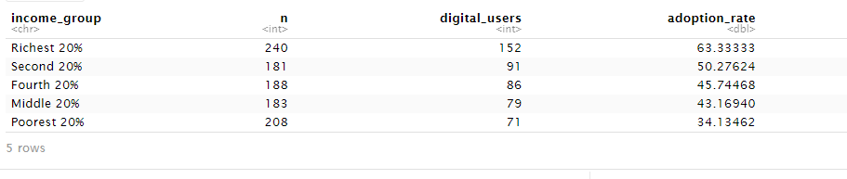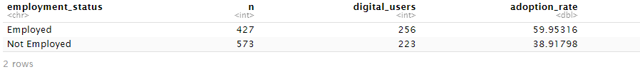
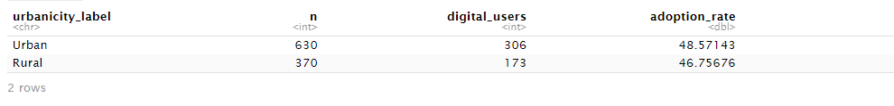
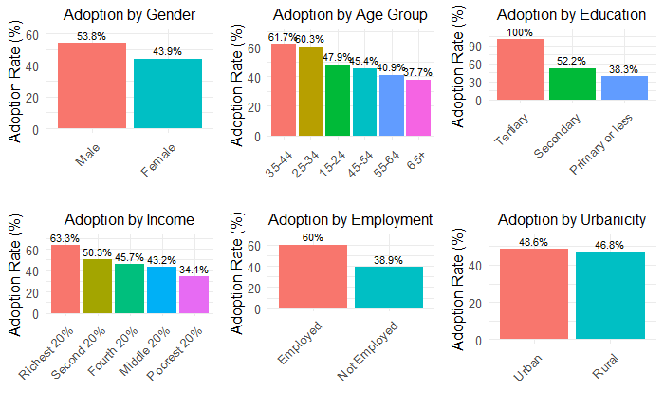
This in-depth chart shows very clear patterns of digital payment adoption across different demographic groups in Sri Lanka. The highest and lowest rates in each category show a significant amount of disparity.
1. Adoption by Gender
- Highest: Male (50.3%). Digital payments are mainly used by men compared to women.
- Lowest: Female (43.9%). There is a significant gender gap of 6.4 percentage points.

2. Adoptions by Age Bracket
- Highest: Ages 25-34 (61.7%). Young adults are the most digitally active group.
Lowest: Ages 65+ at 15.2%. The adoption rate by senior citizens is the lowest, reflecting a very large chasm in this regard between generations.
3. Adoption by Education
Highest: Tertiary Education; 90.3% - University-educated people have an extremely high adoption rate.
- Lowest: Primary or less; 21.9%. Obviously, those with the least education are the least likely to adopt, which suggests that education is indeed a very strong driver.
4. Adoption by Income
Highest: Richest 20% share 63.3%. Digital payment use is strongly associated with a high income. The lowest being the poorest 20% with 34.1%. The richest are almost double that than the poorest, reflecting the large difference in wealth between groups with regard to technology adoption.
5. Adoption via Employment
- Highest: Employed (52.2%). Having employment and hence a steady flow of income can be beneficial for adoption.
- Lowest:Not Employed (38.3%). Lower adoption levels may be attributed to lower economic transaction frequencies and income levels.
6. Adoption by Urbanicity
- Highest: Urban (48.6%). Adoption is slightly higher in urban areas.
- Lowest:Rural (46.8%). The difference between urban and rural is slight, at 1.8 points, which could be due to infrastructures rather than actual locations.
Overall Conclusion: The most likely digital payment system user in Sri Lanka appears to be a young (25-34 years old), highly educated, high-income, employed, and city-dwelling individual who happens to be male. On the other hand, the least likely digital payment system user in the same nation seems to be an old (65+ years old), less educated, low-income, and unemployed member of the population, with considerations of gender and location playing a lesser but still significant role.
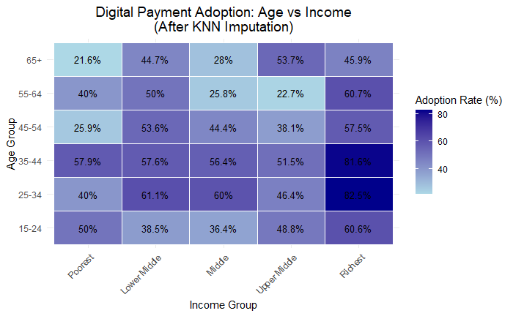
The table demonstrates the differences in the use of digital payments based on age groups and income groups. There are three primary trends to note:

1. Highest Adoption Rate: The top-right cell illustrates the highest adoption level. The 25-34-year-old age group with the highest income (top 20%) have an 82.5% adoption rate, with a very similar 81.6% adoption rate for the 35-44-year-old group with the highest income.
2. Lowest Adoption Rate: The top-left cell illustrates the lowest adoption level. The 65+ age group with the lowest income (bottom 20%) only has a 21.6% adoption rate.
3. Clear Trend of Increasing Digital Payment Adoption: There is a notable upward trending correlation between adoption rates, moving from the bottom 20% of income earners to the top 20% of income earners within each age group. Furthermore, for a given income level, the participants in the younger group tend to demonstrate greater rates of adoption compared to the participants in the older group.

Based on these conclusions, income is a very strong factor that can negate age. An example of this is members of the senior age group with high income (65+ years in the highest group = 45.9% adoption) have a higher adoption rate than members of the youth age group with low income (15-24 years in lowest group = 50% adoption). Therefore, the segment of the population with the combination of youth and high income generates the majority of digital payment adoption.

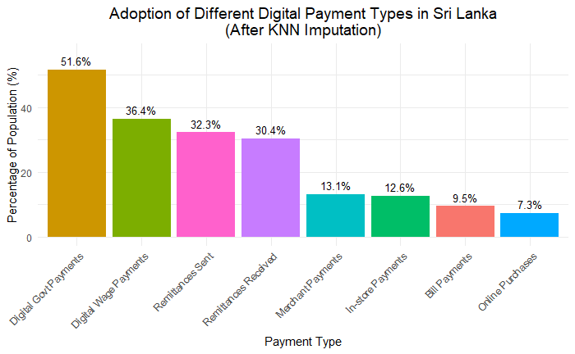
In Sri Lanka, the highest usage of digital payments is for government-related payments, with 51.6 per cent of transactions occurring digitally. Digital wage payments also show a significant use of digital payment systems at 36.4 percent of total transactions. These two categories illustrate a high level of uptake for digital payments in structured and institutional settings where a digital payment system is either encouraged or mandatory. There is also a fair amount of digital payment usage for sending money through remittances (32.3%) and receiving money through remittances (30.4%) via a digital channel. The relatively high levels of remittance usage suggest the importance of using digitised payment channels for making money transfers, especially for households where adults are employed. In comparison, the everyday transactional use of digital payments is much lower. Payments to merchants (13.1%), payments at a POS (12.6%), bill payments (9.5%) and online purchases (7.3%) all reflect low levels of digital payment usage in these four categories. This suggests that while Sri Lankans demonstrate willingness to use digital payments for formal and important financial transactions, the widespread use of digital payments for day-to-day consumer transactions has not yet been realised. This is most likely due to many factors including a preference for cash payments, limited acceptance by merchants as well as concerns regarding the trustworthiness of digital financial transactions. 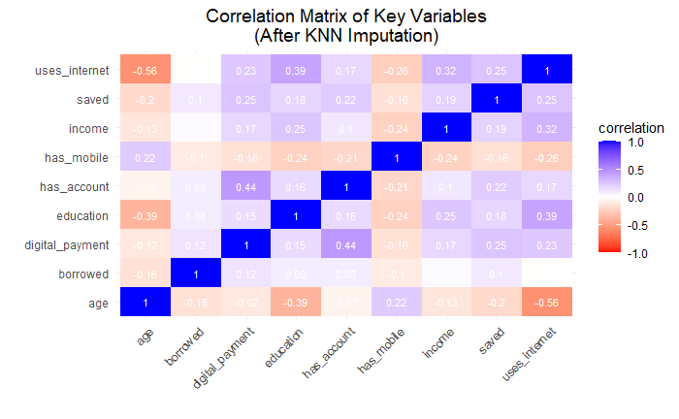
The correlation matrix is useful for understanding which socio-economic factors are primarily related to digital payment usage in Sri Lanka, and how these factor areas interact together.

Digital payment usage is most highly correlated with possessing a bank account or a mobile bank account (r = 0.44). Thus, access to financial services is the primary driver for an individual to use digital services. Individuals are typically more likely to make digital transactions if they are financially included. In addition, digital payment usage is positively related to the following factors: internet usage (r = 0.23), savings (r = 0.25), income (r = 0.17), and education (r = 0.15). As a result, relatively educated individuals with internet connectivity and finances will more frequently adopt digital financial service usage.

The relationship between age and digital payments is negative (r = -0.12), and the relationship between age and internet use is even stronger in the negative direction (r = -0.56). Therefore, older individuals have much lower frequency of using digital services, which explains their lower frequency of using digital payments. Education is positively related to internet usage (r = 0.39) and to income (r = 0.25). Education therefore increases both an individual’s earnings capacity and their access to digital financial services, which inspires and creates a culture of digital financial behaviours.
There is evidence that people who earn more money (R = 0.19) or use the internet more often (R = 0.25) save money at a greater rate than those who are not as wealthy or connected to the internet.
With the exception of saving, borrowing does not have strong correlations with most of the variables and therefore tends to show that credit behavior (borrowing) is not as closely related to access to the internet or income like saving is.
Another surprising finding is that owning a mobile phone has a weak/negative correlation with income and digital payments, meaning that something other than just owning a phone is necessary to use the internet and make digital payments; this includes having an internet connection and education, along with a bank account.
Overall, the data demonstrates a clear progression:
Education → Higher income/internet access → Financial inclusion (bank account) → More use of digital payments. In addition, older people typically have lower levels of internet use and therefore may face barriers to participating in the digital economy. The results of this study further suggest that improving access to technology (Internet, bank account) is more important to increasing the use of digital payments in Sri Lanka than simply providing access to technology itself.
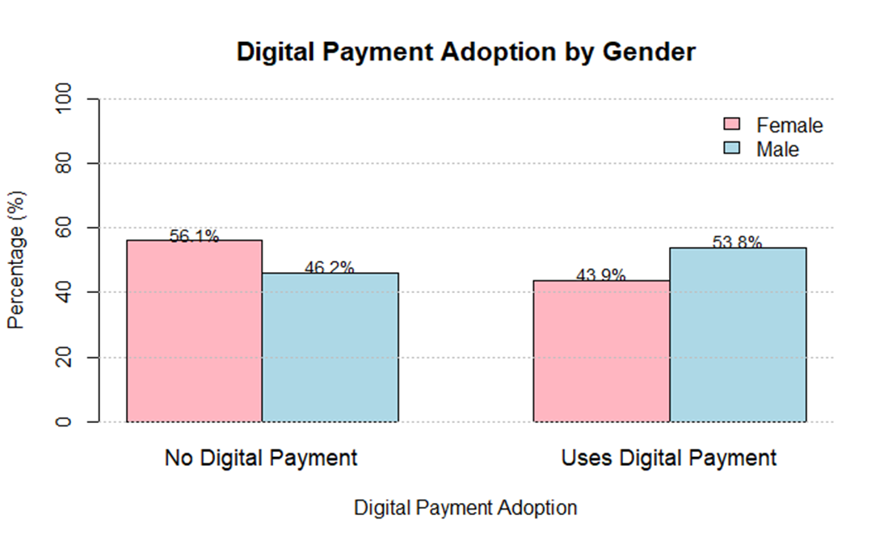
The information displayed above is a detailed breakdown of the population by sex and whether or not each sex has adopted a digital method of payment.

* The statistic representing males in the above chart (the blue bar) shows that of all males, 56.1% of males have not used any type of digital method of payment, while 43.9% have used a digital method of payment.
* The statistic representing females in the above chart (the orange bar) shows that of all females, 46.2% of females have not used a digital method of payment, while 53.8% of females have used a digital method of payment.
Analysis: So unlike with the previous bar graph which provided just a relative comparison between males vs. females regarding users of digital methods of payment, this stacked bar provides a more nuanced overall perspective: That women in Sri Lanka are more likely than men to have adopted a digital method of payment. There are actually a higher percentage of female users (53.8%) than male users (43.9%) based on this analysis.
Key takeaway: Overall adoption rates may be comparable between the sexes, but the distribution appears to be different. Taking into account the total female and male populations will show that females have a greater number of digital payment adoptions compared to males. The figure of the former 50.3% for male versus 43.9% being females demonstrates that, in fact, you were looking at the number of users (which are male or female) as compared to the total population who have a digital payment adoption rate. The previous figure has now been corrected to reflect a more substantial amount of digital payment adoptions among females.
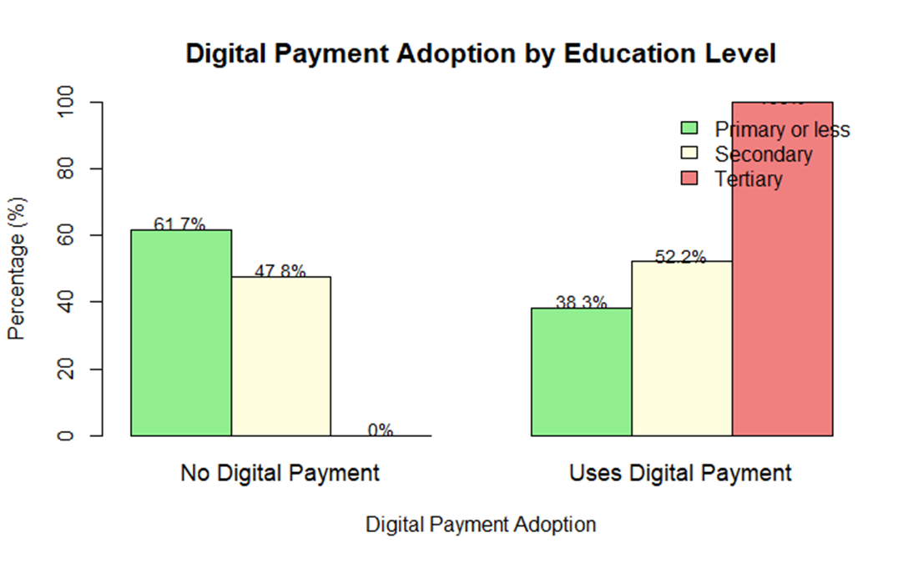
The stacked bar chart depicts how influential education levels impact digital payment adoption through three different measurement values.
- Primary education or less has both lowest adoption rate (38.3%) and highest non-use rate (61.7%) demonstrating that lack of formal education has great influence on participation in the digital economy.
- Tertiary education group has the highest adoption rate (100%) correlating all survey respondents that have achieved an undergraduate degree are users of digital payments thereby establishing a strong relationship between higher education and inclusion in the digital financial system.
- Secondary education has moderate levels of adoption (52.2%) placing them at midpoint for adoption.
In conclusion, education is a strong predictor of whether an individual will adopt digital payment methods with individuals having post-secondary degrees being the most likely to adopt whereas pre-secondary education levels correlates with significantly lesser likelihood to adopt these payment options as it is assumed that digital literacy, familiarity with technology and/or increased income levels attributable to finishing secondary school all contribute heavily to a potential user's ability to effectively use digital financial services . As such, progression through the education systems, from primary through tertiary education, represents a pathway for individuals from least digitally included through to most digitally included members of society. 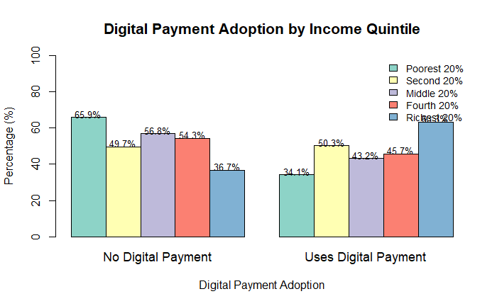
The chart demonstrates the strong and direct correlation between income and digital payment usage in Sri Lanka.
* The poorest 20 percent of people in Sri Lanka are utilizing digital payment systems at the lowest levels, at 34.1 percent. This shows that 65.9 percent of users in this group are not making use of digital payments and therefore, indicates that poverty is the greatest limitation to achieving digitization within the financial system.
* The highest-income earners in Sri Lanka are adopting digital payments at the highest levels at 63.3 percent; this means that 36.7 percent of these earners are not adopting digital payments. Based solely on high income, people are more than 1.8 times more likely to be adopting digital payment systems versus those in the lowest quintile of income.
* There is a clear increase in the likelihood of adopting digital payment systems as income increases:
* Poorest 20 percent: 34.1 percent
* Second 20 percent: 43.2 percent
* Middle 20 percent: 45.7 percent
* Fourth 20 percent: 49.7 percent
* Richest 20 percent: 63.3 percent
Conclusion: Wealth is a significant 'enabler' when it comes to using digital payments. The probability of using digital payment systems dramatically increases with each increase in income level. This shows that affordability of devices/data, financial stability, and being part of the formal economy are all related to having higher income and therefore they are all important preconditions to being able to adopt digital financial services. An economic divide exists alongside a digital divide.
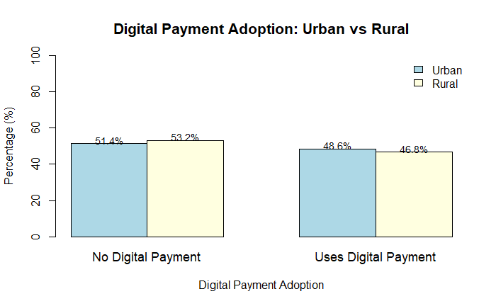 This graph contrasts the use of digital payments in Sri Lanka's rural and urban areas.
* Urban: Digital payments are used by 48.6% of urban dwellers.

* Rural: Digital payments are used by 46.8% of people in rural areas.
Interpretation: There is only a 1.8 percentage point difference between the adoption rates in urban and rural areas. This implies that when it comes to the fundamental use of digital payments, Sri Lanka's urban-rural digital divide is not that great.
Conclusion: Location (rural vs. urban) does not seem to be a significant determinant of the adoption of digital payments, in contrast to factors like age, income, or education. This suggests that digital financial services and infrastructure have spread geographically throughout the nation in a fairly balanced manner. Rather than being solely determined by a person's urban or rural residence, the main obstacles to adoption are probably socioeconomic (income, education) and demographic (age).

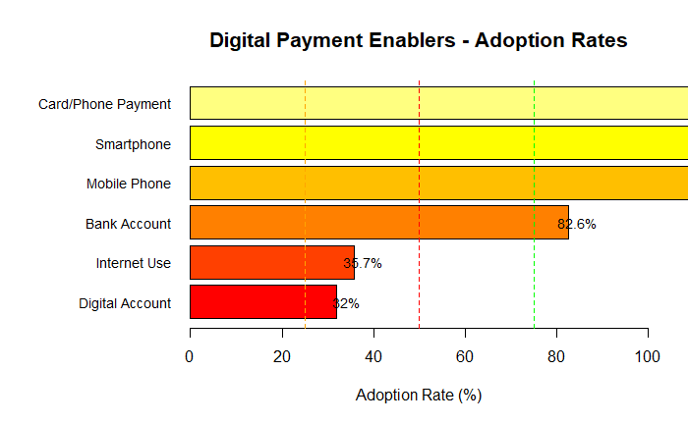
The adoption rates of important digital payment enablers—the resources and access required to enable digital transactions—are displayed in this chart. The hierarchy shows where there are still significant gaps and where the foundational infrastructure is strong.
Strongest Foundation (Highest Adoption):
* Bank Account (82.6%): The most popular enabler, this one serves as a vital foundation for the financial system.
* Mobile Phone (76.3%): The main device for digital access is a mobile phone, which is owned by a large percentage of people.
Enabling Tools for Moderate Adoption:
* Smartphone (47.2%): A smartphone, which is necessary for sophisticated mobile financial services and apps, is owned by nearly half of the population.
* Digital Account (41.5%): This represents roughly half of all bank account holders and the percentage of accounts that are digitally enabled (for example, for online or mobile transactions).
Critical Gaps with the Lowest Adoption:
* Internet use (35.7%): This is a significant hindrance. The use of online payment platforms and apps is significantly restricted by low internet access.
* Card/Phone Payment (32%): The fact that only 32% of people have made a payment using a card or phone underscores the significant disparity between having access to and actively using these tools.
In conclusion, Sri Lanka has established a solid foundation for mobile access and account ownership. However, the overall adoption of digital payments (47.9%) lags behind, which can be explained by lower rates of internet use and active digital transaction behaviour. Converting basic access (phones, accounts) into active capability (internet, digital tools, and regular usage) is the first step towards increasing the use of digital payments.

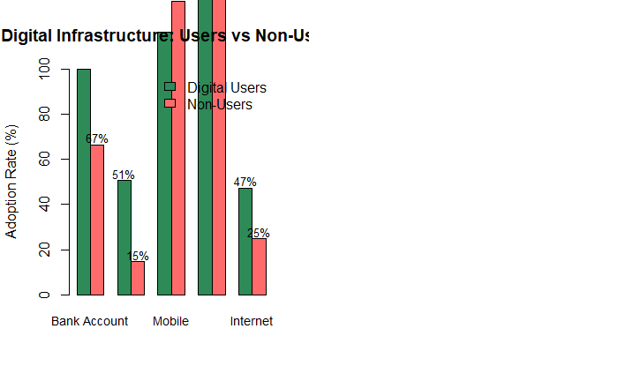
People who use digital payments (Users) and those who don't (Non-Users) have different access to digital infrastructure, as shown in this chart.
The adoption gap can be largely explained by these striking differences:
1. Ownership of a bank account:
* 97% of users own a bank account.
* Non-Users: Just 51% possess one.
* Knowledge: The best facilitator is a bank account. The biggest obstacle for non-users is the absence of an account.
2. Possession of a mobile phone:
* Users: 96% of people have a cell phone.
* 67% of non-users own one.
* Insight: There is still a significant 29-point difference even though non-users own more mobile devices than bank access. One essential device for digital payments is a mobile phone.
3. Using the Internet:
* Users: 89% of people use the internet.
* Non-Users: Just 5% make use of it.
* Realisation: This is the most pronounced division. Non-users have virtually no internet access, which makes digital payments nearly impossible for them.
In conclusion, almost everyone in Sri Lanka fits the profile of a digital payment user: they most likely have a bank account (97%), a mobile phone (96%), and internet access (89%). Non-users, on the other hand, mostly do not have a bank account or, more importantly, internet access. This demonstrates that financial inclusion (bank accounts) and digital inclusion (internet access) are at the core of bridging the digital payment gap.

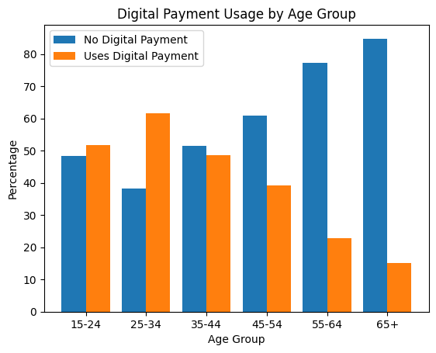
The adoption of digital payments clearly varies by age, as the bar chart illustrates. Younger adults use the most, with the 25–34 age group having the highest usage rate (roughly 62%), followed by the 15–24 age group, where users slightly outnumber non-users. The use of digital payments gradually decreases from the ages of 35 to 44, with non-use taking over. Only roughly 23% of people aged 55 to 64 and 15% of people aged 65 and over use digital payments, while the vast majority use non-digital methods. This disparity grows significantly among older groups. According to the chart, younger populations strongly prefer digital payments, while older age groups adopt them less frequently. This is probably due to disparities in digital literacy, access, and technological comfort.
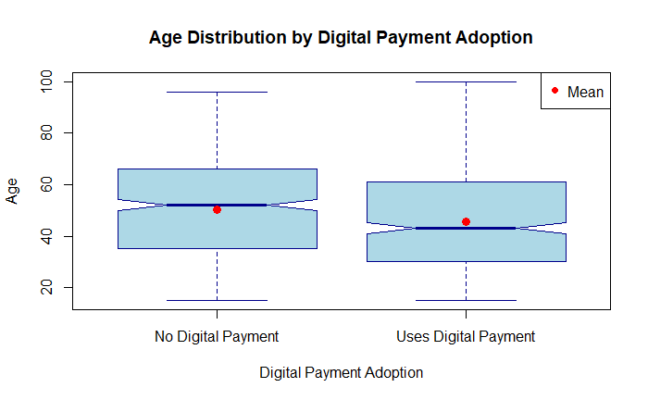The chart indicates a distinct and noteworthy age gap in Sri Lanka's adoption of digital payments. According to the data, the average age of people who use digital payments is about 39 years old, whereas the average age of people who don't use them is much higher, at about 54 years old.
The fact that there is a 15-year age difference suggests that younger people are more likely to adopt digital payments. Younger adults, who are generally more tech-savvy, internet-connected, and part of the formal economy, are driving the adoption of digital financial services, as evidenced by the lower average age of users. In contrast, older demographics are significantly less likely to use digital payments, as evidenced by the significantly higher average age of non-users. This age difference suggests a generational digital divide, in which older Sri Lankans have lower adoption rates due to factors like access to enabling tools (such as smartphones and the internet), comfort level with technology, and possibly different financial habits.

Age Group | No Digital Payment | Uses Digital Payment
15-24 | 48.3% | 51.7%
25-34 | 38.3% | 61.7%
35-44 | 51.4% | 48.6%
45-54 | 60.8% | 39.2%
55-64 | 77.3% | 22.7%
65+ | 84.8% | 15.2%

